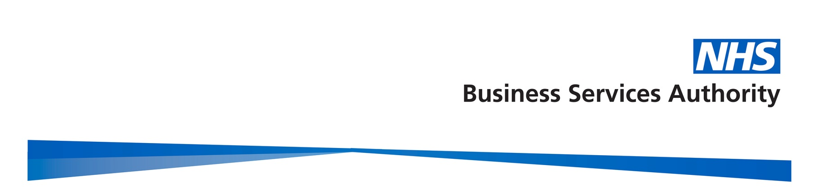

Dear CONTRACTOR,

Pharmacy First service – Advice and Education
This is a service specification reminder on behalf of NHS England to all pharmacies registered to provide the Pharmacy First service.
Accurate record keeping is essential for the safe delivery of the service and to ensure contractors are being correctly remunerated and reimbursed. Pharmacists providing the service should, ordinarily, make their clinical record directly into the Pharmacy First IT system during the consultation with the patient. This allows them to benefit from support and information provided within the IT system, access patient records and ensures timely provision of post-consultation information to the patient’s general practice.
While most Clinical Pathway consultations are delivered in line with the service specification, records indicate that some consultations have been submitted for payment on Manage Your Service (MYS) that may be outside the service as set out in the service specification such as:
Clinical Pathway | High level inclusion criteria | Example outside of service specification
Urinary Tract Infections | Females, aged 16 - under 65 years | Patients who do not meet the inclusion criteria due to their age or gender.
Acute Otitis Media | Children aged 1 - 17 years | Supplies being made to patients over the age of 17 years
Shingles | Adults aged 18 years and over | Supplies being made to children
Acute Sore Throat | Phenoxymethylpenicillin 250mg tablets: 250mg four times a day for 5 days. | Quantities in excess of 20 being submitted. E.g. 28 or 200 (potential typographical errors)

Clinical pathways consultations must only be offered and completed if the symptoms of the patient meet the gateway criteria. As stated in 4.33 of the service specification “A clinical pathways consultation can only be accessed when a gateway point in one of the clinical pathways is crossed.”
In some cases, consultations have been recorded for patients who appear to be ineligible for the service. The data submitted suggests that patients do not meet the high-level criteria for inclusion described in the clinical pathway. As such these patients do not meet the gateway inclusion criteria and so these consultations should not be submitted for payment.
For more information on the Patient Group Directions for Clinical Pathway consultations, please visit the NHSE website here.
Completing a supply within the requirements of the Patient Group Direction (PGD):
A PGD describes the strict inclusion and exclusion criteria under which a supply of a prescription only medicine can be made (e.g. a person’s age / gender) and provides the written instructions for that supply to take place. It also describes what can be supplied, as well as the exact formulation, dosage and quantities that can be supplied. It is unlawful to make supplies outside of the PGD instructions and it may raise a clinical safety risk.
Contractors are responsible for ensuring that the data submitted for the service delivery accurately reflects the service that has been delivered.
The Drug Tariff is currently being reviewed to clarify (from 1st February 2025) that where data supplied to the NHSBSA suggests that the provision of a clinical pathway consultation was not in accordance with the appropriate PGD or service specification, payments may be withheld by the NHSBSA whilst the claims are reviewed. Payments will be authorised if the contractor provides sufficient evidence to demonstrate that the supply was in accordance with the appropriate PGD or service specification.
NHSE has requested the Provider Assurance Team (PAT) to undertake a programme of Post Payment Verification activities with the pharmacies with the highest numbers of claims that do not appear to be in accordance with the service specification. This engagement will commence later this month.

In the meantime, all pharmacies providing the Pharmacy First service are requested to:
- Review any consultations that may not have been completed in accordance with the service specification or resulted in an inappropriate supply being made and take appropriate clinical action e.g. contacting patients; notifying the patient’s general practice; making a record using the Learn from Patient Safety Events service;
- Review their delivery of clinical pathways and data submission to ensure that their service delivery meets the requirement of the service specification, including, for example, that the Gateway Point for the pathway is met; or that any supplies made fully meet the criteria of the relevant PGD;
- Ensure that accurate patient records are kept in relation to each consultation so that evidence is available of the reasons for supply should any claims be the subject of investigation or challenge by the PAT team as part of Post Payment Verification;
- Review their claims before submission for payment to ensure that they are in accordance with the service specification and fully meet the criteria of the relevant PGD.

For more information or for clarification of any of the details in the letter, please contact us using the details below.

Email us: pharmacysupport@nhsbsa.nhs.uk
Telephone us: 0300 330 1295

Your co-operation is very much appreciated.

Yours sincerely,

The Provider Assurance Team
Pharmaceutical – Assurance Services

Email and Microsoft Teams: pharmacysupport@nhsbsa.nhs.uk
Website: Provider Assurance | NHSBSA | Telephone Number: 0300 330 1295
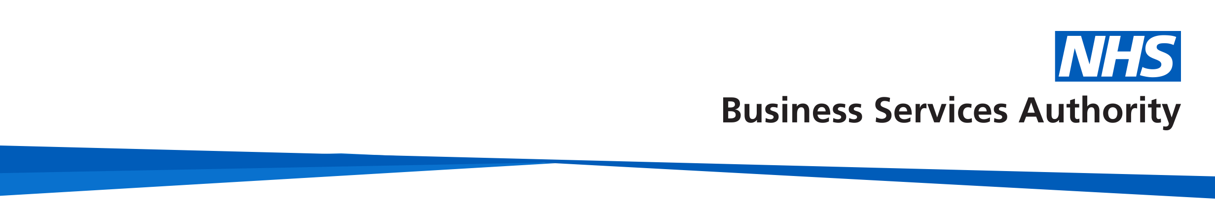
Please read our email disclaimer online at: http://www.nhsbsa.nhs.uk/email.
To reduce our environmental footprint, please only print when necessary.

https://www.legislation.gov.uk/uksi/2012/1916/contents/made

