If you are part of a pharmacy group or multiple, please liaise with your company managers/head office as necessary.

SUBJECT | REQUIREMENT | DEADLINE | ACTIONS AND LINKS | TICK WHEN COMPLETED
Community Pharmacy Assurance Framework (CPAF) screening questionnaire | Contractual | 1-31st July Completion Window | Pharmacy contractors will shortly receive confirmation from NHS BSA that the CPAF screening questionnaire will go live on 1 July 2025 and will be available for completion until midnight on 31 July. Users of NHS BSA’s Manage Your Service (MYS) portal will be able to complete this year’s CPAF by logging in. The small number of contractors who do not have a sign-in for MYS will be able to complete the questionnaire online and will receive an email setting out details on how to do this. Completion of the screening questionnaire is compulsory. The results will be used to determine which contractors receive a monitoring visit and who will be asked to complete the full CPAF survey.
Community Pharmacy Event-  An Update on Weight Management Services | Information | 6th July 2025 at 9:30am | Join us at the Hilton Leicester (21 Junction Approach, Leicester, England, LE19 1WQ for an update on Weight Management Services.  We will have guest speakers: Shelia Chauhan–Moon Mounjaro, Satyan Kotecha and Rahul Patel Weight Management Service (Safe, Effective and Ethical) and Mike Skarlatos Medical Educator & Dietitian. This event is open to all Pharmacists and Pharmacy Team Members.  Training and Events 2025 – Community Pharmacy Leicestershire and Rutland
Shortened Manual Claim Journey for MYS NHS Discharge Medicines Service (NHS DMS) | Contractual | 6th July 2025 | As many of you begin to prepare for your end of month claiming process; Please find below information below claim journey for MYS for DMS  DMS: Shortened claim journey on MYS from July 2025 - Community Pharmacy England  Pharmacy owners are reminded of the actions they need to take ahead of this coming into effect on 6th July 2025.
2025 Community Pharmacy England Workshops - Book your place now | Contractual | 9th July 2025 | Make a difference: meet with CPE on 9th July.  Event details  Date: Wednesday 9th July  Time: 8pm-9.30pm (doors open from 7pm for refreshments, with informal networking and Q&A with the CPE team)  Venue: Holiday Inn South Normanton M1, JCT.28, Carter Lane East, DE55 2EH Get involved  https://cpe.org.uk/our-news/eastern-and-east-and-north-midlands-pharmacy-owners-book-on-your-local-future-of-pharmacy-workshop/
Shared Care Records for LLR Community Pharmacies webinar | Information | 24th July 2025 | We’re pleased to invite all LLR community pharmacies to join an upcoming webinar on the Shared Care Records—whether your pharmacy is currently enrolled or not.  Time: 1:30 – 2:00 PM  This is a great opportunity to understand the benefits, ask questions, and explore how it fits into the future of integrated care.  We look forward to seeing you there!  Join the meeting now  Meeting ID: 314 868 986 844 1  Passcode: iq7qx7FL
Invitation to Webinar & Pilot Opportunity – Smart Respiratory Inhaler Dongle | Information | 29th July 2025 | We are pleased to invite you to a webinar on Tuesday 29th July from 1:30–2:00pm, where we will be joined by Smart Respiratory to introduce an exciting pilot opportunity for all community pharmacies across LLR.  Smart Respiratory are seeking volunteer community pharmacies to participate in this pilot by collecting and analysing data from patient-returned MDIs.  Join the meeting now  Meeting ID: 382 299 476 665 1  Passcode: 6Ps2ed64
Statutory Consultation – Pharmaceutical Needs Assessments (PNAs) for Leicester, Leicestershire & Rutland | Contractual | 8th August 2025 | You are formally invited to respond to the consultation. Please review at least one of the draft PNAs – for Leicester, Leicestershire, or Rutland – and complete the associated questionnaire.  Links to each draft PNA and questionnaire are available below:  Leicestershire: https://www.leicestershire.gov.uk/have-your-say/current-engagement/pharmaceutical-needs-assessment-2025  - Leicester: https://consultations.leicester.gov.uk/public-health/pna-2025  - Rutland: https://www.rutland.gov.uk/have-your-say/pharmaceutical-needs-assessment  If it makes it easier for you or your organisation to respond to the consultation by letter or email, please do so. Please send your response to Hanna Blackledge, Helen Reeve or Amy Chamberlain, as appropriate, at the contacts given below.  - Leicestershire draft PNA documents, please contact Hanna Blackledge (Hanna.Blackledge@leics.gov.uk)  - Leicester City draft PNA document, contact Helen Reeve on 0116 454 2021 or (Helen.Reeve@Leicester.gov.uk)  - Rutland draft PNA documents, contact Amy Chamberlain (Amy.Chamberlain@leics.gov.uk )
Order Only What You Need Campaign | Service Income | ACT NOW –  4th August | The LLR Order Only What You Need campaign in conjunction with LLR ICB is now live and all LLR community pharmacies can participate. Each participating contractor will receive £100 payment.  Only Order What You Need – Community Pharmacy Leicestershire and Rutland
CPCF Changes:  Summary of  Regulatory Changes | Contractual | Ongoing | ▪ Find out more about the changes scroll down to view our summary timeline or read more here  Watch the on-demand recording of our contract changes webinar here
NMS Changes to claiming | Service Support | Ongoing | A new claiming process has been confirmed for NMS  ▪ Make yourself familiar with the new process and latest updates here
Access the benefits of using the LLR Care Record for you and your team | Service Delivery |  | If you think your team would benefit from LLR Care Record access, or would like refresher training including latest features such as the timeline and sharing of assistive equipment details, simply email lpt.llrcarerecord@nhs.net. Training, usually delivered via MS Teams, takes less than an hour and can be tailored to your needs.  https://leicesterleicestershireandrutland.icb.nhs.uk/your-care-record/
Pharmacy First – Patient Feedback Request | Service Delivery | Open until end of 2025 | Ask your patient to give feedback on Pharmacy First to help inform service improvements.  Find out more here
NHS Mail Pharmacy | Pharmacy IT | ACT NOW | Access regularly (at least once a month). Ensure you access your personal NHS.net email regularly (at least once every 30 days) to avoid your account being deleted Further  information is available here
Social media; Join us! | Information | ACT NOW | Facebook  Instagram  LinkedIn
Mailing List and WhatsApp group | Information | ACT NOW | Encourage your Locum and Relief Pharmacists to join our mailing list to ensure they are up to date with the latest news and local updates.  Please contact Rajshri, Chief Officer (details below)

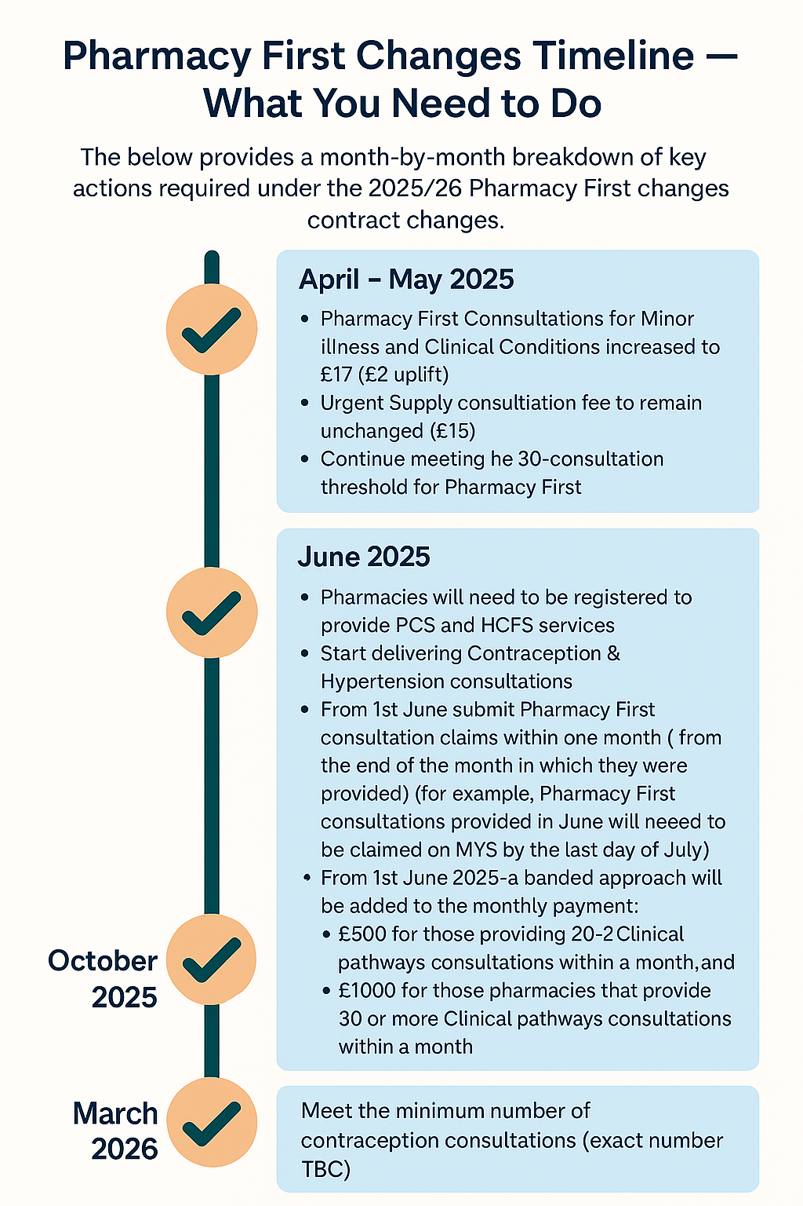
National Health campaigns for July 2025
Alcohol Awareness Week | Information | 9-13th July 2025 | A chance for the UK to get thinking about drinking. It’s a week of awareness-raising, campaigning for change, and more.  Alcohol Change
South Asian Heritage Month | Information | 18th July – 17th August 2025 | Aims to raise the profile and contribution of British South Asian history in the UK.  South Asian Heritage Month

If you require additional support from the administrative team, please contact any member of the team:
Rajshri Owen- Chief Officer | chiefofficer@leics-lpc.co.uk
Kate Blockley-Smith– Administrator | admin@leics-lpc.co.uk
Vinay Mistry-Service Development Lead | servicedevelopmentlead@leics-lpc.co.uk

