If you are part of a pharmacy group or multiple, please liaise with your company managers/head office as necessary.

SUBJECT | REQUIREMENT | DEADLINE | ACTIONS AND LINKS | TICK WHEN COMPLETED
Reminder  Pharmacy First -Thresholds | Pharmacy Income | Monthly | - £500 for those providing 20-29 Clinical pathways consultations within a month; and  - £1000 for those pharmacies that provide 30 or more Clinical pathways consultations within a month.  Check activity early in week 3 or 4 of each month.
Christmas/ New Year 2025/26 community pharmacy rota | Information | ACT NOW | The Christmas 2025/26 bank holiday rota can be found here
Directory of Services | Pharmacy Services | 31st December 2025 | The deadline for meeting the requirement is the 31st of December 2025  This is a mandatory requirement for all pharmacy owners  Action: Updated your NHS website profile and your DoS profile using NHS Profile Manager
Pharmacy First – Patient Feedback Request | Service Delivery | 31st December 2025 | Ask your patient to give feedback on Pharmacy First to help inform service improvements.  Find out more here
PharmOutcomes Access | Information & Support | ACT NOW | Check that pharmacy staff have access to PharmOutcomes during all opening times, especially when locums are on duty; set-up additional accounts if needed. Instructions can be found here.  Ensure PharmOutcomes is checked regularly throughout the day and action any referrals received.
CPE Funding & reimbursement shorts | Operational Support | Ongoing | A new ‘End of Month Submission Process’ Short has been released  - View the video and important information here
Pharmacy Quality Scheme- The Antimicrobial Stewardship Clinical Audit | Service Income | Last start date 3rd February 2026 | Pharmacy First consultations clinical audit can be started from the 1st September 2025  ▪ The 2025/26 clinical audit should be conducted from 1st September 2025 and completed no later than 31st March 2026 ▪Read more HERE
NHS Mail Pharmacy | Pharmacy IT | ACT NOW | Access regularly (at least once a month). Ensure you access your personal NHS.net email regularly (at least once every 30 days) to avoid your account being deleted Further information is available here
Social media; Join us! | Information | ACT NOW | Facebook  Instagram  LinkedIn
Join our WhatsApp community |  |  | 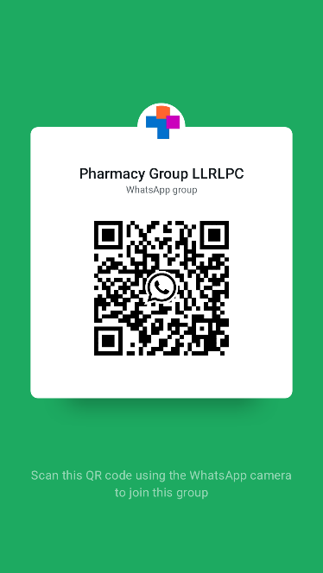
Join our Instagram community |  |  | 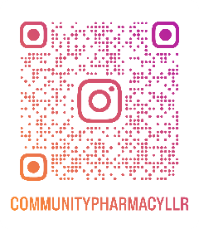

National Health campaigns for December 2025
World Aids Day | Information | 1st December 2025 | An opportunity for people worldwide to unite in the fight against HIV, to show support for people living with HIV, and to commemorate those who have died from an AIDS-related illness.  World Aids Day
International Day of People with Disabilities | Information | 3rd December 2025 | Since 1992, the United Nations IDPD has been annually celebrated around the world.  UN IDPD

If you require additional support from the administrative team, please contact any member of the team:
Rajshri Owen  Chief Officer | chiefofficer@leics-lpc.co.uk  To book an appointment with our Chief Officer please click HERE
Admin Office | admin@leics-lpc.co.uk
Vinay Mistry  Service Development Lead | servicedevelopmentlead@leics-lpc.co.uk  To arrange a FREE services support visit please click HERE

As we come to the end of 2025, we want to express our sincere thanks to all community pharmacy teams across Leicester, Leicestershire and Rutland for your outstanding hard work, resilience and dedication throughout the year. From delivering Pharmacy First at scale, supporting winter pressures, managing medicines challenges and providing daily compassionate care to thousands of patients, your contribution has been nothing short of extraordinary.
We are incredibly proud of everything you have achieved.
Wishing you and your teams a very happy Christmas and a peaceful, healthy and successful New Year.

Thank you for everything you do for our communities, day in and day out. Here’s to a positive and impactful 2026 together.

